1.Configure your user name and email.

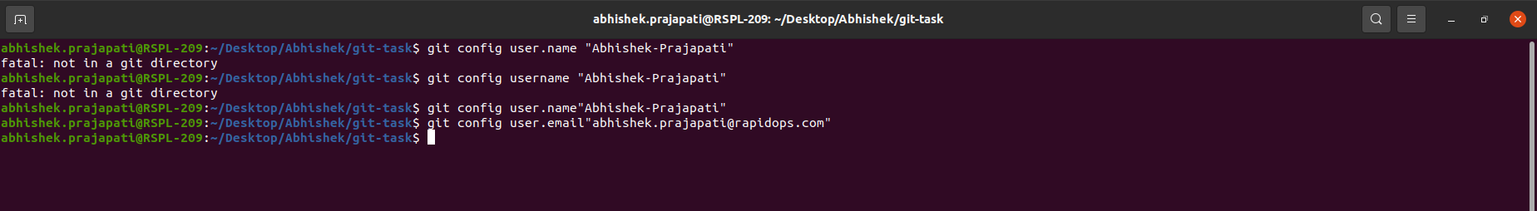
F
2.Clone repo of your name from GitHub to the local system.

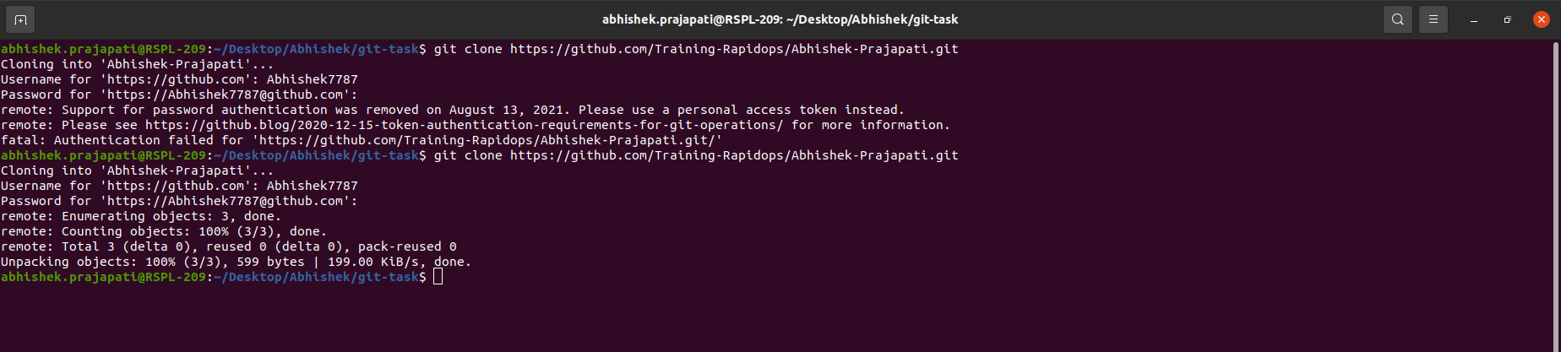
3.Create a file inside the repo, and make your first commit "My First Commit".

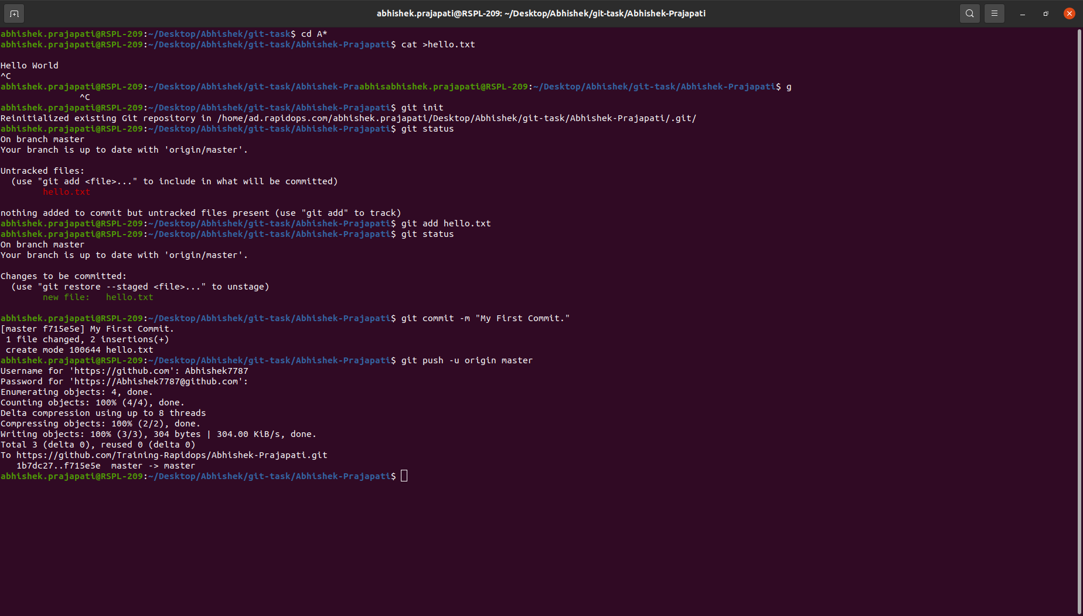
4.Create and switch to the branch 'test/development' (create from the master branch and it should be from origin).

5.Add a file in this branch and commit your changes with the message "Practice started in test branch".
6.Now push your changes and this branch to the remote.

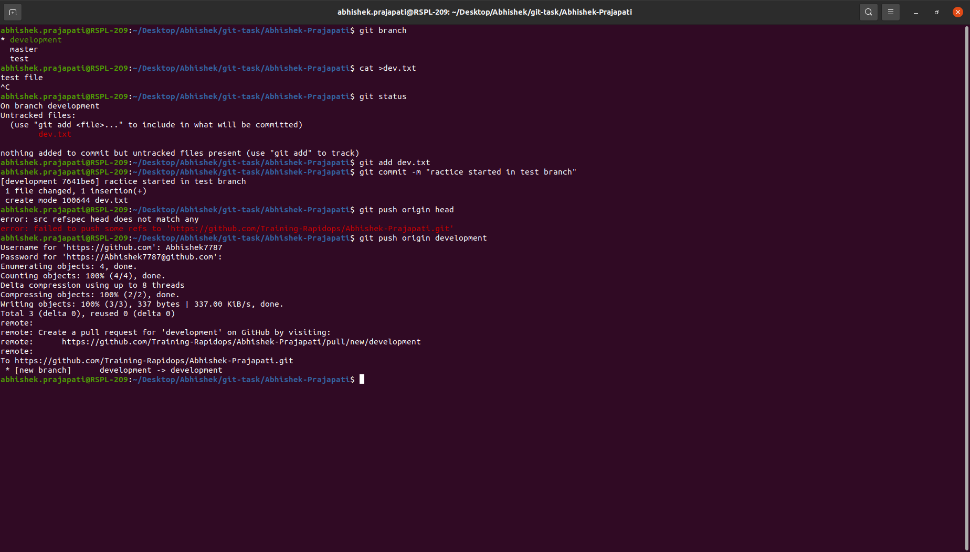

7.Go to your GitHub repository and create a pull request to merge this branch in master. Also, add Ravindra & your mentor as reviewers.
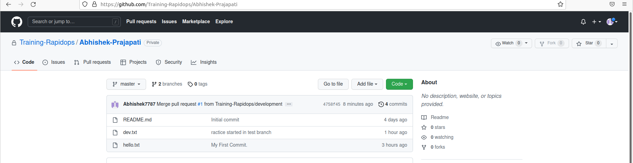

8.Fork a public repository Test-Training

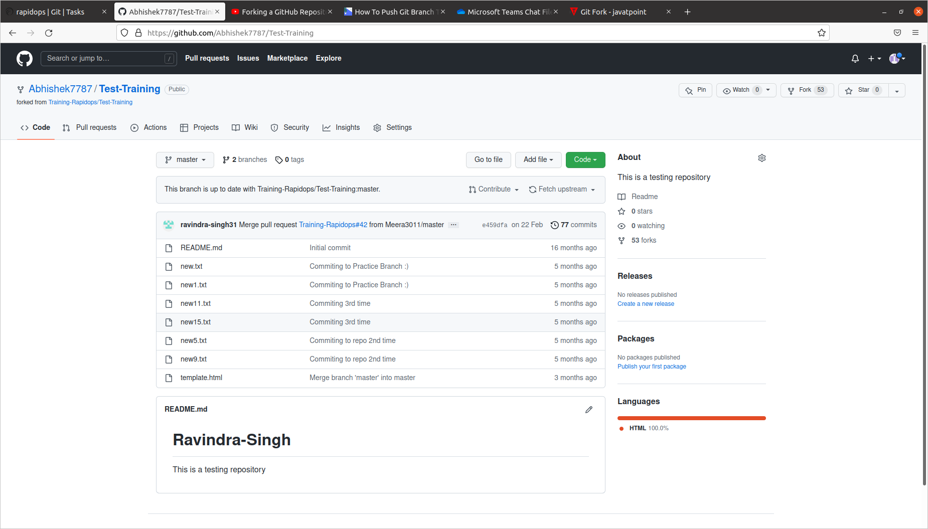

9.Make a change in the template.html file by adding 'author: {your-name}' and add commit 'Author updated by {your-name}'.

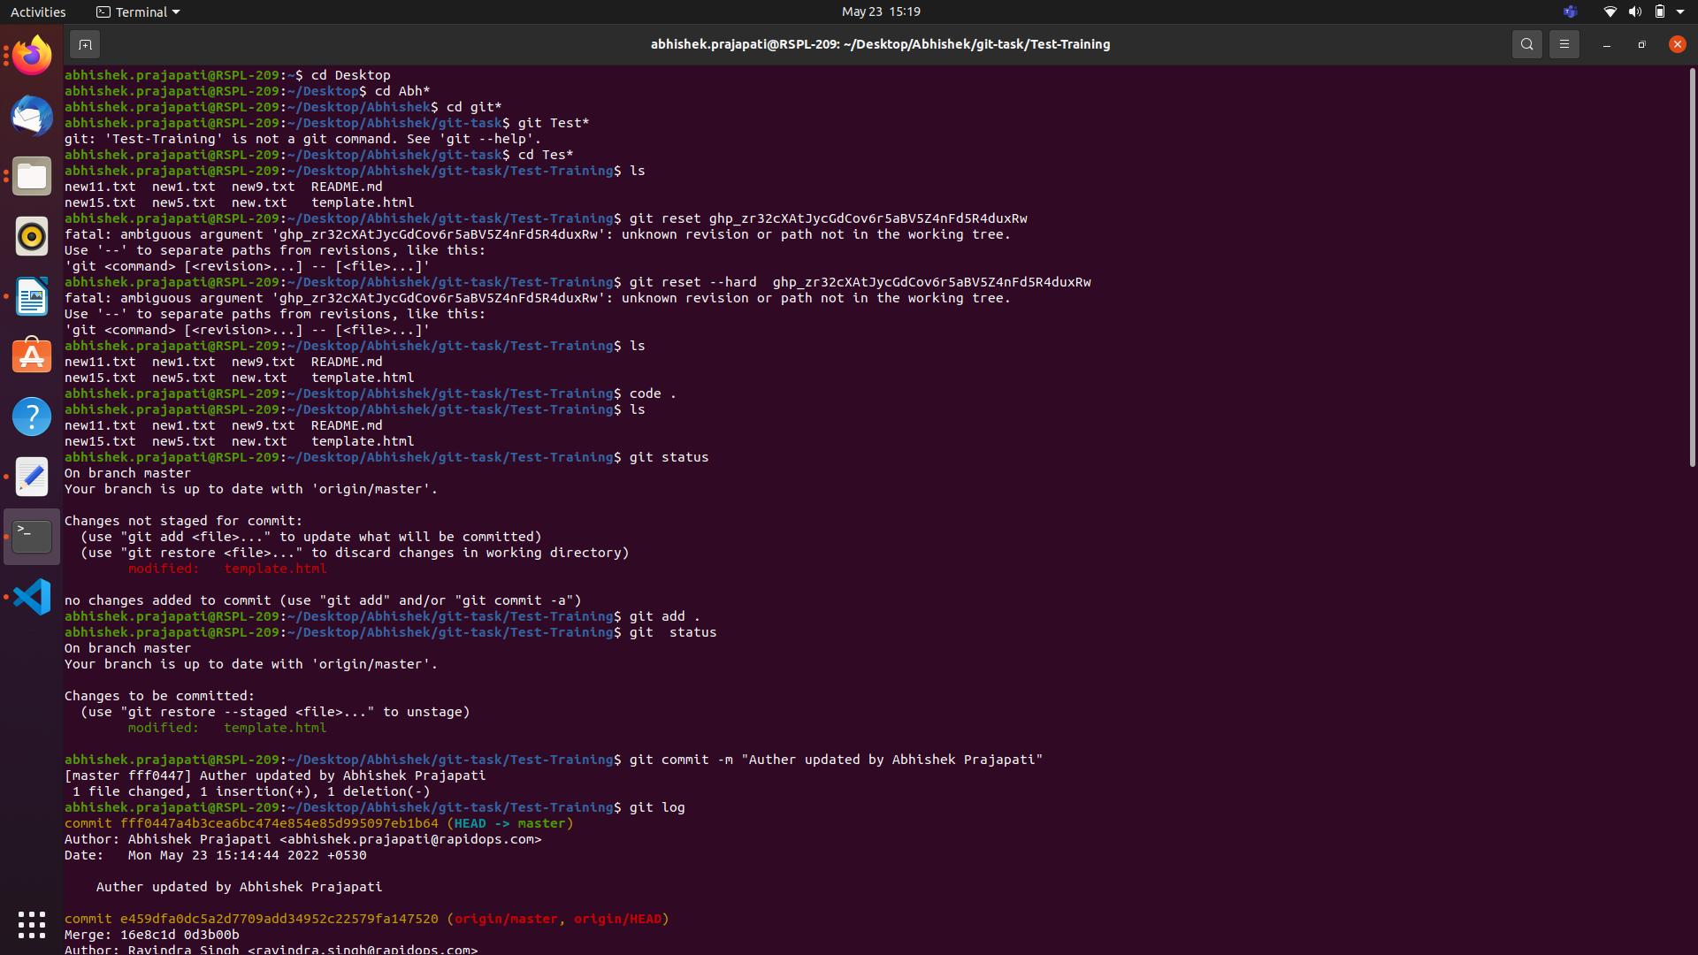

10.Give PR to merge your forked repo in the Test-Training repo.

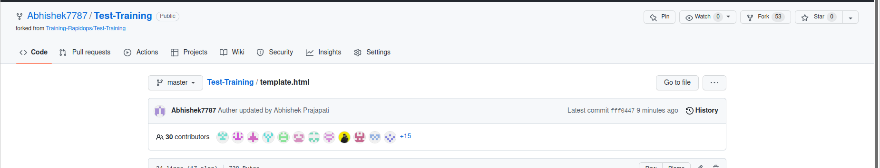

11.Come back to your repo, where you create a branch 'practice' and add 3 commits then rebase it with the master.

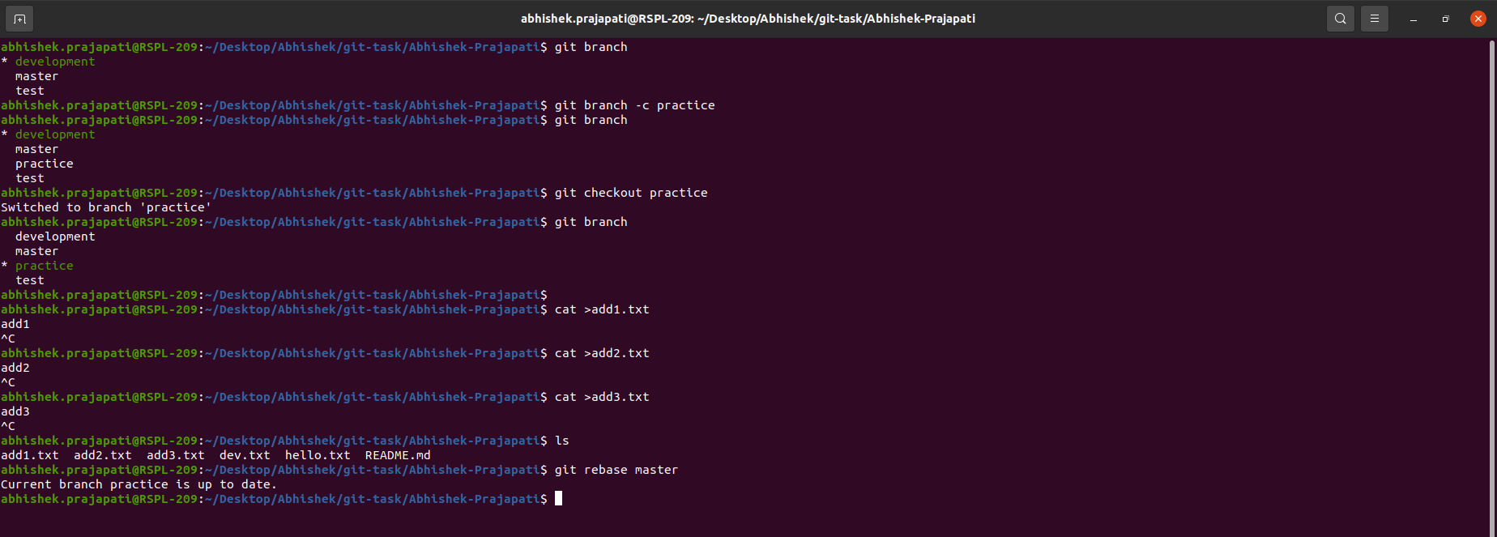

12. Push your changes to remote, then Add 3 commits again and squash them into the first commit by keeping the message "Rebase squash done".

13.Now revert these changes but note that the changes must be retained in the commit history. (use default revert commit message)

14.Reset your last commit without losing the changes and then commit with the message "Finished revert with staging changes".

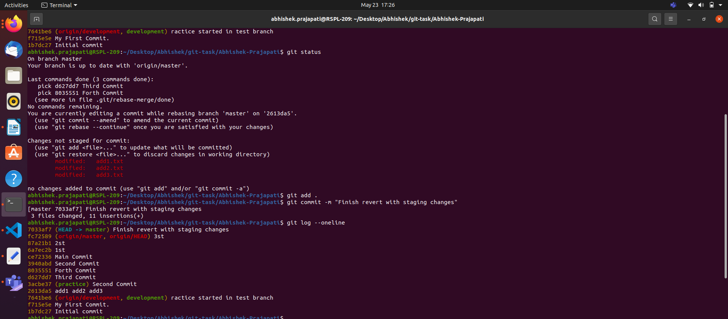

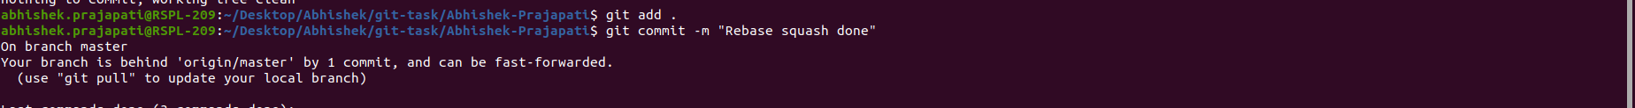
15.Create one commit then perform a hard reset such that you're back to the commit with the message "Rebase squash done".

16.Create a file index.html, and add it to the staging index then stash it.
17.Check the list of stash, what changes are there in the stash, then bring your changes from stash.
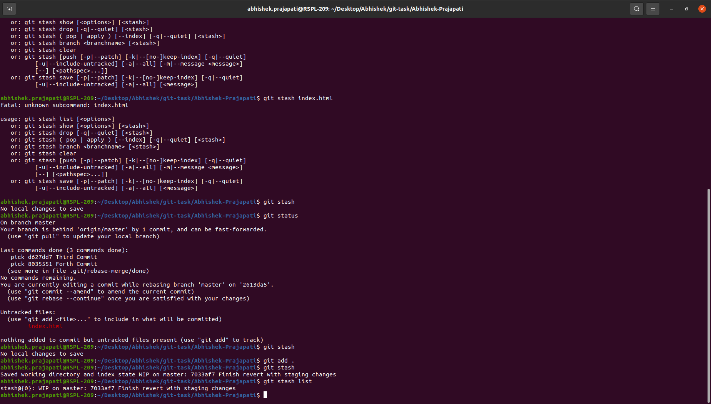

18.Commit with a message "Revert, Reset & Stash done".

